Breast Cancer Gene Expression Analysis Using Machine Learning

Internship Project Report
Submitted in partial fulfillment of the requirements for the completion of the Internship

Submitted by
MUKESH VARATHAN A A
M.Sc. Microbiology
B.S. ABDUR RAHMAN CRESCENT INSTITUTE OF SCIENCE AND TECHNOLOGY
CHENNAI

Organization : BIOTECHTREK
Internship Domain
AI and Machine Learning in computational biology
Duration : 2 Months

Submission date : 07/07/2026

Acknowledgement

I express my sincere gratitude to my internship mentor and all the faculty members who provided valuable guidance and encouragement throughout this project.

I am thankful to my department for providing the opportunity to work on a bioinformatics and machine learning project that enhanced my understanding of computational biology and gene expression analysis.

I also acknowledge the National Center for Biotechnology Information (NCBI) Gene Expression Omnibus (GEO) database for providing publicly available breast cancer gene expression datasets that made this study possible.

TABLE OF CONTENTS

S.NO | CONTENTS | P.NO
1 | INTRODUCTION | 4
2 | ABOUT THE INTERNSHIP | 5
3 | TOOLS USED | 6
4 | METHODOLOGY/WORKFLOW | 7
5 | PROJECT WORK | 9
6 | SKILLS GAINED | 12
7 | CHALLENGES FACED | 12
8 | CONCLUSION | 13
9 | WORKFLOW | 14

1. Introduction

1.1 About the Organization
BioTechTrek is a biotechnology training and career development organization that provides practical learning opportunities in biotechnology, bioinformatics, computational biology, artificial intelligence (AI), machine learning (ML), and related life science domains. The organization focuses on bridging the gap between academic education and industry requirements through internships, workshops, and project-based learning. It also offers mentorship, career guidance, and hands-on training to help students develop industry-relevant technical skills.

1.2 About the Internship
This internship was conducted at BioTechTrek in the domain of Artificial Intelligence and Machine Learning for Bioinformatics. The internship aimed to provide practical exposure to Python programming, data preprocessing, feature selection, machine learning model development, and biological data analysis.

1.3 Introduction to the Project
Breast cancer is one of the most common cancers affecting women worldwide. Early diagnosis significantly improves treatment outcomes and survival rates. Gene expression profiling enables the analysis of thousands of genes simultaneously, allowing researchers to identify molecular differences between normal and cancerous tissues. In this project, the publicly available GSE15852 breast cancer gene expression dataset obtained from the NCBI Gene Expression Omnibus (GEO) database was analyzed using Python-based machine learning techniques. After data preprocessing and feature selection, three supervised machine learning algorithms—Logistic Regression, Support Vector Machine (SVM), and Random Forest—were developed and evaluated. The performance of these models was compared using accuracy, confusion matrix, ROC curve, and feature importance analysis to identify the most effective classifier for breast cancer prediction.

2. About the Internship
The internship was undertaken at BioTechTrek with the objective of gaining practical knowledge in the application of Artificial Intelligence (AI) and Machine Learning (ML) in the field of bioinformatics. The internship focused on developing computational skills required for analyzing biological datasets using Python and machine learning techniques.
During the internship, training was provided on Python programming, data preprocessing, feature selection, supervised machine learning algorithms, data visualization, and model evaluation. Practical sessions were conducted using real biological datasets to understand the complete workflow of machine learning-based data analysis.
As part of the internship project, a publicly available breast cancer gene expression dataset (GSE15852) obtained from the NCBI Gene Expression Omnibus (GEO) database was analyzed. The project involved preprocessing the gene expression data, selecting informative genes, developing classification models using Logistic Regression, Support Vector Machine (SVM), and Random Forest algorithms, and evaluating their performance using accuracy, confusion matrix, ROC curve, and feature importance analysis.
The internship provided valuable exposure to computational biology and strengthened practical skills in bioinformatics, machine learning, data analysis, and scientific problem-solving. It also enhanced the understanding of how artificial intelligence can be applied to healthcare and disease prediction.

3. Tools Used
- Python 3.13
- Visual Studio Code (VS Code)
- Anaconda
- Pandas
- NumPy
- Scikit-learn
- Matplotlib
- NCBI Gene Expression Omnibus (GEO)
- Microsoft Excel

4. Methodology / Workflow

Step 1: Problem Definition
Biological Problem: Identification of breast cancer samples using gene expression data.
Research Objective: To develop and compare machine learning models for accurate classification of normal and breast cancer tissues.
Expected Outcome: To identify the best-performing machine learning algorithm and the most informative genes associated with breast cancer.

Step 2: Data Acquisition
The breast cancer gene expression dataset (GSE15852) was downloaded from the NCBI Gene Expression Omnibus (GEO) database. The dataset contains 86 samples (43 normal and 43 breast cancer tissues) with expression values for 22,283 genes. The data were provided in a Series Matrix (.txt.gz) format.

Step 3: Data Preprocessing
The series matrix file was imported into Python using the Pandas library. Metadata rows were removed, and only the gene expression matrix was extracted. The dataset was transposed so that rows represented samples and columns represented genes. Class labels were assigned to distinguish normal (0) and tumor (1) samples.

Step 4: Exploratory Data Analysis (EDA)
Basic exploratory analysis was performed by examining the dataset dimensions, column names, data types, statistical summary, and sample information to understand the structure and quality of the dataset before model development.

Step 5: Feature Engineering
Feature selection was performed using the SelectKBest method with the ANOVA F-test to identify the top 100 informative genes. This reduced the dimensionality of the dataset and improved model efficiency.

Step 6: Machine Learning Model Development
Three supervised machine learning algorithms were implemented:
- Logistic Regression
- Support Vector Machine (SVM)
- Random Forest
Each model was trained to classify breast cancer and normal tissue samples based on gene expression profiles.

Step 7: Model Training
The dataset was divided into training (80%) and testing (20%) sets using the train_test_split() function with stratified sampling to ensure equal representation of both classes during training and evaluation.

Step 8: Model Evaluation
The trained models were evaluated using multiple performance metrics, including Accuracy, Precision, Recall, F1-score, Confusion Matrix, ROC Curve, and Area Under the Curve (AUC). Model performance was compared to determine the most effective classifier.

Step 9: Biological Interpretation
Random Forest feature importance analysis was performed to identify the top 20 genes that contributed most to breast cancer classification. These genes may serve as potential biomarkers for future biological studies.

Step 10: Reporting
The complete workflow, methodology, model performance, and results were documented. Graphs including confusion matrices, ROC curves, feature importance plots, and model comparison charts were generated to support the findings.

5. Project Work

5.1 Project Title
Breast Cancer Gene Expression Analysis Using Machine Learning Algorithms

5.2 Project Objective

Problem Statement
Breast cancer is one of the leading causes of cancer-related deaths among women worldwide. Early and accurate identification of cancerous tissues using gene expression data can improve diagnosis and support timely clinical decision-making.

Aim
To develop and compare supervised machine learning models for classifying normal and breast cancer samples using gene expression data.

Scope
- To analyze breast cancer gene expression data obtained from the NCBI GEO database.
- To preprocess and prepare the dataset for machine learning analysis.
- To perform feature selection for identifying informative genes.
- To develop Logistic Regression, Support Vector Machine (SVM), and Random Forest classification models.
- To compare the performance of different models using evaluation metrics and identify the best-performing algorithm.

5.3 Dataset Description
The dataset used in this project was obtained from the National Center for Biotechnology Information (NCBI) Gene Expression Omnibus (GEO) database. The dataset selected for analysis was GSE15852, titled "Expression data from human breast tumors and their paired normal tissues." This dataset contains gene expression profiles generated using microarray technology and is publicly available for research purposes.
The dataset consists of 86 samples, including 43 normal breast tissue samples and 43 breast tumor tissue samples. Gene expression values were measured for 22,283 genes, providing a high-dimensional dataset suitable for machine learning analysis.
The dataset was downloaded in Series Matrix (.txt.gz) format and imported into Python for preprocessing. During preprocessing, metadata were removed, the expression matrix was extracted, and the data were transposed so that each row represented a sample and each column represented a gene. Binary class labels were assigned to distinguish normal tissues (0) from breast cancer tissues (1).
This dataset was selected because it contains paired normal and tumor samples, making it appropriate for developing and evaluating machine learning models for breast cancer classification.

5.4 Workflow Followed
- Collected the breast cancer gene expression dataset (GSE15852) from the NCBI GEO database.
- Imported the dataset into Python and performed data preprocessing.
- Assigned labels to classify samples as Normal and Tumor.
- Split the dataset into training and testing sets.
- Selected the top 100 important genes using the SelectKBest feature selection method.
- Trained three machine learning models:
  - Logistic Regression
  - Support Vector Machine (SVM)
  - Random Forest
- Evaluated the models using Accuracy, Precision, Recall, F1-score, Confusion Matrix, and ROC Curve.
- Compared the performance of all three models.
- Identified the best-performing model and the top important genes using Random Forest feature importance.

5.5 Results Obtained

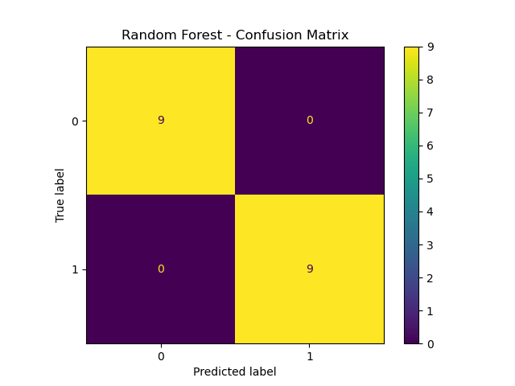
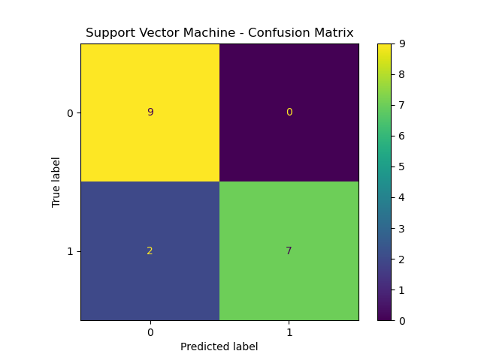
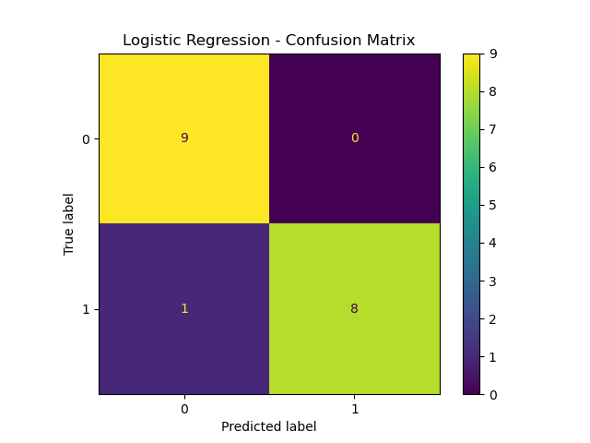

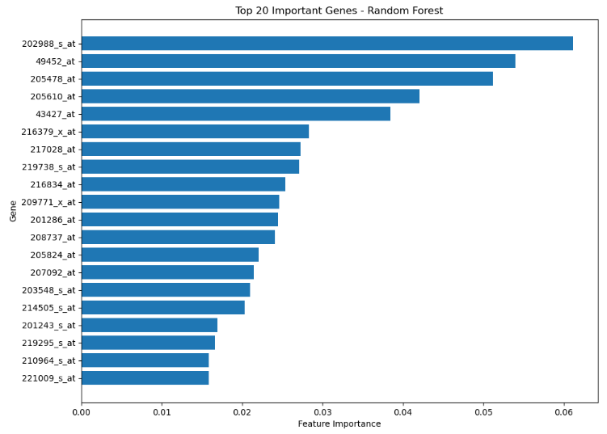
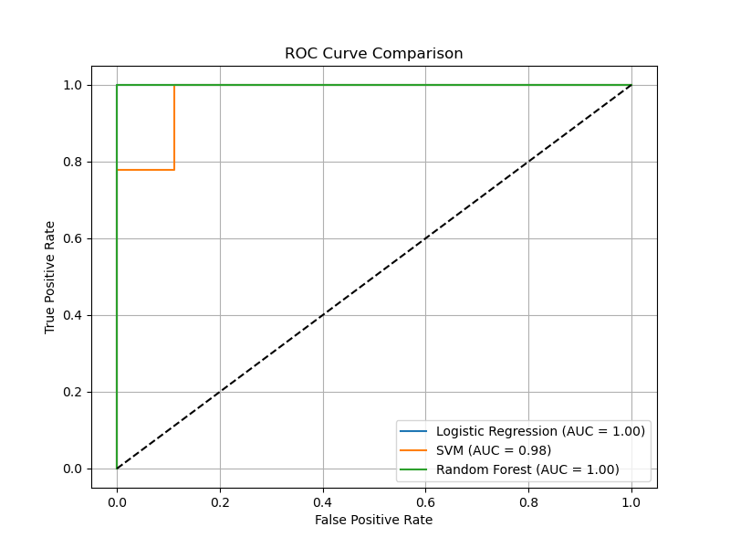

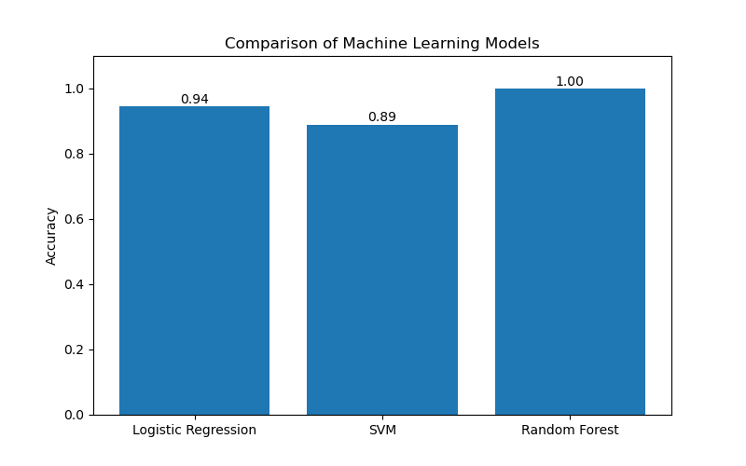
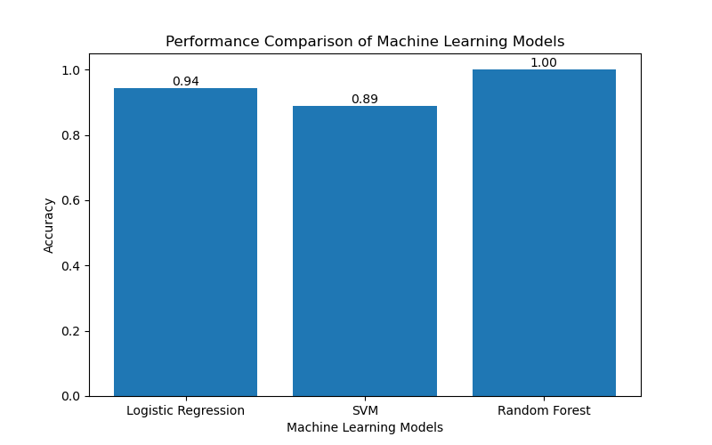
The breast cancer gene expression dataset (GSE15852) was successfully preprocessed and analyzed using Python. After preprocessing, the dataset contained 86 samples (43 normal and 43 breast cancer samples) with expression values for 22,283 genes.
The dataset was divided into training (80%) and testing (20%) sets. Feature selection was performed using the SelectKBest method, reducing the number of genes from 22,283 to the top 100 informative genes.
Three supervised machine learning algorithms were implemented and evaluated:
- Logistic Regression
- Support Vector Machine (SVM)
- Random Forest
The performance of each model was compared using accuracy, precision, recall, F1-score, confusion matrix, and ROC curve.
Among the three models, Random Forest achieved the highest classification performance with an accuracy of 100% on the testing dataset. Logistic Regression achieved an accuracy of 94.44%, while Support Vector Machine achieved an accuracy of 88.89%.
Feature importance analysis using the Random Forest model identified the top 20 genes that contributed most to breast cancer classification. These genes may serve as potential biomarkers for further biological investigation.
Overall, the results demonstrated that machine learning algorithms can effectively classify breast cancer samples based on gene expression data, with the Random Forest model providing the best performance for this dataset.

6. Skills Gained
During the internship, I gained both technical and analytical skills in the fields of bioinformatics and machine learning. The major skills acquired are:
- Python Programming
- Data Preprocessing and Data Cleaning
- Gene Expression Data Analysis
- Machine Learning Model Development
- Feature Selection Techniques
- Model Evaluation and Performance Analysis
- Data Visualization using Matplotlib
- Bioinformatics Data Handling
- Problem Solving and Analytical Thinking
- Scientific Documentation and Report Writing

7. Challenges Faced and Solutions
Challenges Faced | Solutions Implemented
Understanding the GEO Series Matrix file format | - Studied the dataset structure and extracted the expression matrix using Python.
Handling a high-dimensional dataset (22,283 genes) | - Applied SelectKBest feature selection to reduce the dataset to the top 100 informative genes.
Learning machine learning concepts | - Practiced different algorithms and understood their implementation through Python.
Comparing model performance | - Evaluated each model using multiple performance metrics such as accuracy, confusion matrix, ROC curve, and feature importance.
Interpreting biological results | - Analyzed the important genes identified by the Random Forest model and related them to breast cancer classification.

8. Conclusion
This internship provided valuable practical exposure to the application of artificial intelligence and machine learning in bioinformatics. A publicly available breast cancer gene expression dataset (GSE15852) from the NCBI Gene Expression Omnibus (GEO) database was successfully analyzed using Python.
After preprocessing the dataset and selecting the top 100 informative genes, three machine learning algorithms—Logistic Regression, Support Vector Machine (SVM), and Random Forest—were developed and evaluated. Among these models, Random Forest achieved the highest classification accuracy of 100%, outperforming Logistic Regression (94.44%) and Support Vector Machine (88.89%).
The project demonstrated that machine learning techniques can effectively classify breast cancer samples based on gene expression profiles. It also enhanced my understanding of Python programming, data preprocessing, feature selection, model evaluation, and bioinformatics workflows. Overall, the internship strengthened my technical skills and provided practical experience in applying computational methods to solve biological research problems.

WORKFLOW

Breast Cancer Gene Expression
Dataset (GSE15852)
│
▼
Data Collection (NCBI GEO)
│
▼
Data Preprocessing
(Cleaning & Data Formatting)
│
▼
Feature Matrix Preparation
│
▼
Train-Test Split (80% : 20%)
│
▼
Feature Selection (SelectKBest - Top 100 Genes)
│
▼
Machine Learning Model Development
┌─────────────┬─────────────┬─────────────┐
│ │ │
▼ ▼ ▼
Logistic Support Vector Random
Regression Machine (SVM) Forest
└─────────────┴─────────────┴─────────────┘
│
▼
Model Evaluation
(Accuracy, Precision, Recall, F1-score,
Confusion Matrix & ROC Curve)
│
▼
Feature Importance Analysis
(Top 20 Important Genes)
│
▼
Model Performance Comparison
│
▼
Final Result & Conclusion

